June 2018 Newsletter
Calhoun Community High School
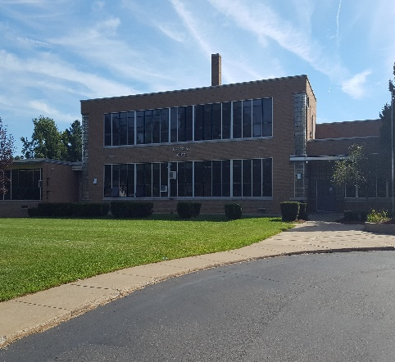Upcoming Events
May 25 – Student Support Day
May 28 - No School, Holiday
June 7 – Half Day for Students Graduation luncheon at 11:30 a.m. Rehearsal from 1:00-3:00 p.m. in Lakeview Middle School Auditorium 6:00 p.m. Grads arrive at LMS Graduation Ceremony at 7:00 p.m. (get there early!)
June 8 – Last Day of School for students (half day)
Important Announcements
6/7 Graduation at Lakeview Middle School in the Auditorium, at 7:00 p.m. Practice will also be at LMS at 11:30 a.m. after half day dismissal at 10:55 a.m., lunch will be served. Practice is for students walking in the graduation ceremony, no parents will be admitted. Lifetouch will be on site taking graduation photos so please dress accordingly, there is no obligation to purchase photos. Graduates ARE ALLOWED to TASTEFULLY decorate caps for the ceremony. Use common sense when decorating; Profanity, drug/alcohol references, or anything in poor taste will not be tolerated.

Like us on Facebook
15 Arbor Street, Battle Creek
www.calhounhs.org T: 269-565-2460

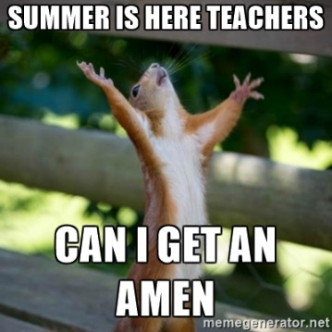
June Birthdays

Abdiel Melendez 6/2
Chase Dailey 6/5
Mary Soto 6/6
Zach Pancost 6/12
Cammie Spranger 6/16
Makenzi Richardson 6/17
Jordon Baldwin 6/23
William Gray 6/27
Garrett Wilson 6/28

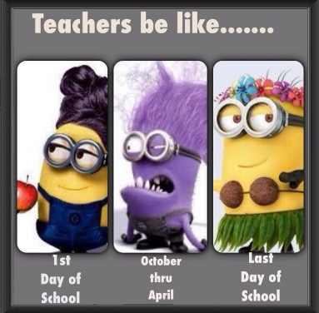

Summer School Schedule:

Mon. 7/11–Thurs. 7/14, 8:00-12:00
Mon. 7/18-Thurs. 7/21, 8:00-12:00
Mon. 7/25-Thurs. 7/28, 8:00-12:00

Parent feedback is very important to us at CCHS. Help us improve by taking the Parent Survey below. We are always looking for input from our Parents.
http://bit.ly/CCHSParentSurvey2017-18
Graduates: Good news! Mr. Allard and the School Board are allowing grads to decorate graduation caps this year for the ceremony. Your decorated cap MUST BE APPROVED by Mr. Allard. Caps and gowns will be handed out during the luncheon on June 7th before rehearsal, so you will have the afternoon to be creative! It is important to remember to use your best judgment when being artistic. If any grads have profanity, drug/alcohol references, graphic or obscene words/phrases/pictures, we will confiscate your cap. Take this opportunity to be creative and clever, don’t ruin it for the class of 2019 next year.
OPEN ENROLLMENT FOR NEXT FALL BEGINS AUGUST 1ST. ANYONE INTERESTED MAY EITHER PRINT ENROLLMENT PAPERWORK OR STOP IN THE OFFICE TO PICK UP A PACKET. ENROLLMENT INFO CAN BE FOUND UNDER THE PARENTS’ LINK ON OUR WEBSITE www.calhounhs.org. PLEASE CALL THE OFFICE WITH ANY QUESTIONS AT (269) 565-2460.
DO YOU KNOW ANYONE INTERESTED IN ATTENDING CCHS? REFER A FRIEND!

Congratulations to the Graduating Class of 2018
Mariana Allen Sabrina Gates Zach Reagle
Tanighga Allison Zoe Hillman Chase Reed
Darrell Allred Taylor Hoffman A.J. Rosales
Hannah Amaro Jacob Howard
Veronica Antes Bryan Jones Tiffany Rue
Jalyn Arredondo-Fisher Cadon Jones Anthony Schaub
Dustin Bennett Jesse Jones-Mitchell Lucas Secord
Kaylee Berryhill Taylor Jordan Brittany Snell
Zack Bolden Michael Kent Katrina Snell
Austin Bonney Cody Keeton Cammie Spranger
Sunshine Bradshaw Anthony Knapp Lindsey Stone
Britain Burr Chris Lafon Josh Suedmeyer
Jordan Busick Cassie Lafriniere Emilie Standish
Ariel Camera Autumn Lewman Kyle Starkweather
Joey Carlton Veronica Mayes Chy’Ann Tatum
Ivan Cesco Chyna Miner Jenna Thorp
Arielle Converse Alex Nelson Jacob Underwood
Haley Crandall Tyler Newsom Dante VanMeter
Alicia Cummings Britney Nicholas Damarie White
Shelby Farmer William Nichols Jordan Wood
Jayden Flora Erin Owens Tyler Zelochowski
Skylynn Ford James Parker Taylor Zimmerman
Seth Fox Asa Pendygraft
Joe Garcia Michael Ramey-Sands

What are your summer plans?

Mr. Allard: will be hosting family from Florida and Colorado in June, flying to Wilmington, N.C. in July, attending annual canoe trip in August and playing all the golf I can squeeze in.
Mrs. Ruhstorfer: will be mowing her lawn, working, or sleeping!
Mrs. Case: will be working summer school in June, traveling to Europe in July, on Grandma duty, and attending 3 weddings in August.
Mr. Digby: will be working in my yard, and relaxing at the lake AND ocean.
Mrs. Wilsey: will be at one of three places; on my deck, a shoe store, or Lake Michigan.
Mrs. Pease: will be anywhere Mrs. Wilsey goes.
Mr. Mathis: will be getting into trouble somewhere at all times.
Ms. Learman: will be working on college classes, visiting my family in the “Thumb”, helping Mr. Digby and Mrs. Pease take care of the school garden, and spending time with my boyfriend.
Mrs. Edwards: will be hanging out with her babies, binge watching Netflix, gardening and cooking.
Mrs. Goodale: I will be graduating one son next month from High School, hosting an Open House, attending several Open Houses, adding a new driver (my middle son), attending lots of out of town baseball and lacrosse tournaments and hopefully going somewhere with my husband for my 20 year Anniversary.
Gabby Eggleston: Going swimming at Eagle Lake and job hunting.
Zack Bolden: staying home and sleeping as much as possible.
Keegan Banks: Working at Steak ‘N Shake, and hanging out with friends.
Sapphire Kisinger: Ditto!
Korbin Fletcher: Job hunting!
Attention Parents: Included in this mailing is a table that includes data on your student's grades as they relate to attendance as well as test scores from fall and spring in the Measurement of Academic Progress (MAP) test. If scores are missing in the MAP test section it is because your student didn't take that particular test. Use the chart provided to see where they fall with regards to grade level equivalency. If you need help understanding the information, please contact the school and we will assist you.

