May 2019 Newsletter
Calhoun Community High School
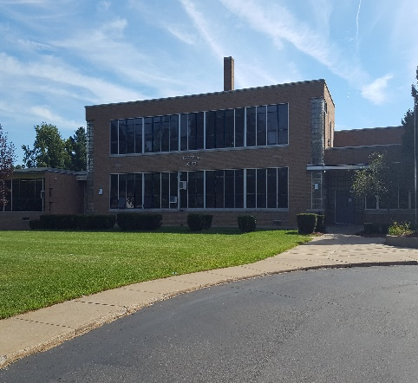Upcoming Events
5/9 – Parent/Teacher Conferences 3:00-6:00 p.m., no appt needed
5/10 – Student Support Day, only students with poor attendance/grades need attend
5/24 – Last day for Graduating Seniors
5/27 – No School
5/30 – Half Day, last day of classes for 4th Qtr – Graduation 7:00 p.m., practice at 11:30 a.m. at LMS
5/31 – Student Support Day, only students with poor grades/attendance need attend
Important Announcements

The graduation luncheon on 5/30 will be held at Lakeview Middle School cafeteria at 11:30 a.m. Immediately following lunch, graduation practice will be held in the Middle School auditorium. Practice will last about an hour. Please return to the Middle School for the ceremony by 6:30 p.m.

Like us on Facebook
15 Arbor Street, Battle Creek
www.calhounhs.org T: 269-565-2460

May Birthdays
Trenten Cohoon 5/3
Kasey Hodgkinson 5/4
Bobby Collins 5/4
Mrs. Case 5/4
Steven Lint 5/13
Gabby Eggleston 5/15
Matt Knowles 5/16
Lexi Thomas 5/17
Aislynn Bryant 5/18
Dylan Perry 5/24
Mrs. Olsen 5/28
Cheyenne Burdick 5/30
James Freeze 5/31

After-school Math and English are available on the following days:
Tuesdays and Wednesdays 2:30 – 4:30 p.m.
Ms. Learman and Ms. Ruhstorfer are here for you!

Summer Birthdays!
Happy Birthday to all the students (and Mathis) that have birthdays after school gets out!
June
Abdiel Melendez 6/2 Jacob Clements 6/21
Chase Daily 6/5 Blake Thurman 6/27
Davi’Ayre Vandeburg 6/21 Garrett Wilson 6/28

July/August
Emma Derrick 7/14 Luke Isaacson 7/16
Serenity Brown 7/28 Jacob Clay 7/28
Braeden Hinton 7/18 Mathis 8/15
Important Graduation Information to Remember:
- If you have not already ordered, Cap & Gown fees are $45.00. You can pay by check, cash, or money order in the office. (Payable to Calhoun Community High School).
- Baby/toddler & graduation/current picture were due by April 17th. Either bring into school or email Mrs. Wilsey at dwilsey@calhounhs.org.
- Last day for graduating seniors is Thursday May 24th.
- Graduation is on Thursday May 30th in the Lakeview Middle School auditorium at 7:00p.m. There will be a mandatory luncheon in the cafeteria at 11:30, where we will hand out caps & gowns. There will be a rehearsal for the graduation ceremony following lunch.
MAY 7 . 7:15AM
KELLOGG ARENA . BATTLE CREEK
TICKETS: Free for students

Come hear an inspiring story of survival and success! Austin Hatch overcame the odds to play basketball at the University of Michigan after battling back from two plane crashes that claimed the lives of his family. Listen as he shares the power of faith, discipline and a positive outlook.
The Community Prayer Breakfast is an affiliate fund of the Battle Creek Community Foundation.
battlecreekcommunityprayerbreakfast bcprayer
Anyone interested in attending, please sign up in Student Services. Transportation to Kellogg Arena is your responsibility, please arrive by 7:00 a.m. CCHS staff will transport back to school after the breakfast. Please see Mrs. Seifke or Mrs. Olsen with any questions.

Summer School
Summer school will be starting on June 3^{rd,} from 8:00 a.m.-12:00 p.m., Monday through Thursday. Letters will be mailed the week of May 20th to students that are required to attend. Summer school will be held at 15 Arbor St.
If you have any questions or concerns, please contact the office at
(269) 565-2460.

What a busy year it has been.
Tim Allard, Superintendent

Do you ever find yourself say the same thing over and over again? Every year I find myself saying, “Can you believe it’s already May?” This year, like so many others, has flown by so fast. With our shortened school calendar this year, we will be done on May 31st. Graduation is Thursday, May 30th. It’s hard to believe we are at the end of the school year already. For me, the biggest task for this year has been preparing for our move. In September and October we weren’t even sure we were going to be able to move as we didn’t have a secure location. In November, we found the Burma Center and began to formulate the relationship with them to potentially move there. December and January were spent working out a lease and securing an architect for building improvements and renovations. February was the month we worked out the lease agreement. March was spent reviewing drawing and securing bids for technology infrastructure and a building contractor. April was the month we planned demolition and construction planes and timelines, and now, in May the work to demo and remodel the building begins. In June we will pack up the current school and move our contents to the new facility where it will be stored until August when we get our occupancy permit. Mrs. Reid and I will work this summer as usual. In June we will work from our current location and in July we will find a space to work at the new building. By August we will be able to set up the office and classrooms so we can have an open house. September will be business as usual in our new building and on we will go. It has definitely been a busy, exciting, year and I can’t wait to see how next year goes.

