Calhoun Community high school
2020 Top Ten

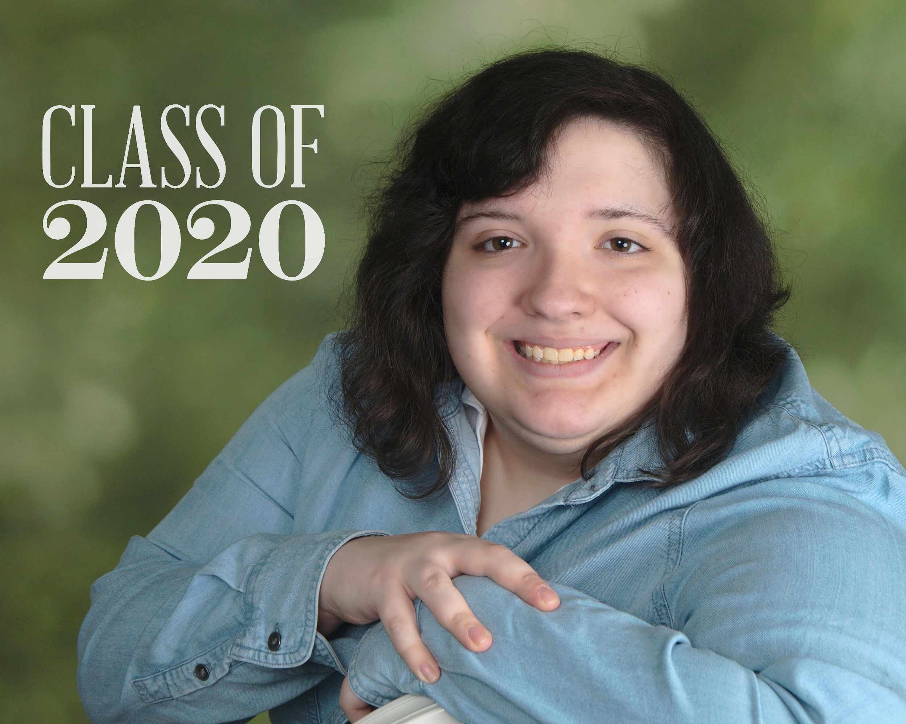
Gabriela Eggleston, Valedictorian
Parents/Guardian: Christopher & Susan Eggleston
Gabriela's future plans after high school include furthering her education in Welding. She will begin by attending Kellogg Community College where it is her goal to obtain her Certificate in Welding and enter an apprenticeship upon completion at KCC. From there, it is her goal to obtain her Journeyman's license to further her career. Her future plans also include eating a lot of Taco Bell.
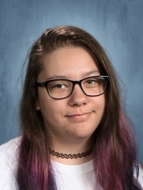
Kierstyn Vanbruggen, Salutatorian
Parents/Guardians: James Vanbruggen and April Hicks. Kierstyn plans on moving to Kentucky and buying her own place. Kierstyn would like to pursue a career in photography and she is very determined to make that goal happen.
Stephine Dill
Parents/ Guardians: Gary Dill, Eleanor Boyers, and Natasha Banks.
Stephine is a part of the EMT program at KCC and CACC. After her completion of the program she would like to pursue the paramedic program at Kellogg Community College where she will decide her future career options.

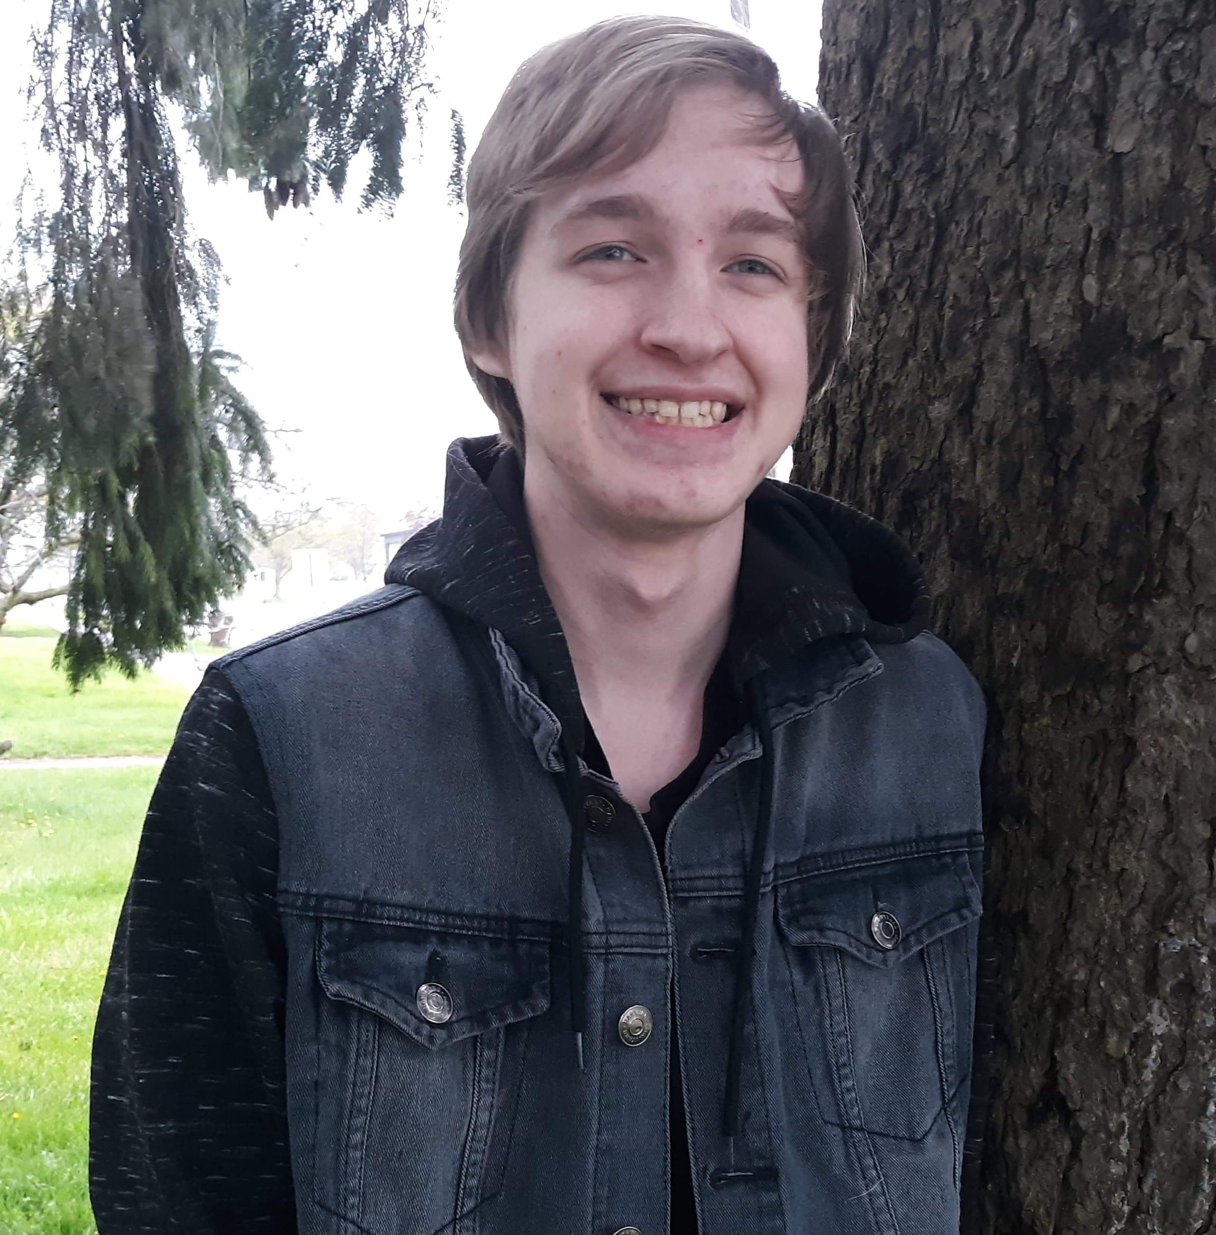
Gabriel Birgy
Parents/Guardians: Mark and Hannah Birgy from Charlotte, Michigan. Gabe states that a memorable highlight from his Freshman year was when he was in an Honors Choir, and was able to take a trip with the choir to New York City, where they sang for an audience at Carnegie Hall. Gabe's favorite classes always involved science and animals, as he has loved animals since he was 2 years-old. After graduation Gabe plans on attending Lansing Community College for an Associate's Degree, and then plans on transferring to a university, where he will major in biology.

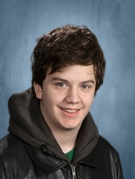
Korbin Fletcher
Parents/Guardians: Christy (Norm) Chapin and Keith Fletcher, Also Proud Grandparents include Tom & Connie Bracke, Helen & Don Larder, and Dorothy Fletcher all of Battle Creek. His Life Verse is 2 Chronicles 15:7 “But as for you, be strong and do not give up, for your work will be rewarded.” Korbin began attending Calhoun Community School in 2017.

Korbin participated in Kellogg Community College’s robotic building club, Bruin Bots. He was active on CCHS’s student council and participated in several student clubs including cooking, photography, and game club. He has completed 40 hours in Kellogg Community College’s RMTC manufacturing program. Korbin is an avid video-game player and enjoys gathering with his friends weekly to play card & board games.

Next year, Korbin intends to continue at the RMTC and complete his certificate in Industrial Welding.
His Senior Quote: "Add this. This. This Quote" - Bruce Greene

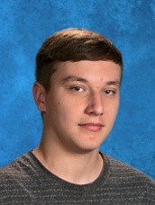
Garett Wilson
Parents/Guardians: Marge and David Wardell, Merritt and Sheila Wilson
Garret is glad to be done with high school and looks forward to his future plans of being a strong Leader in the working community.

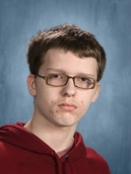
Scot Stanford
Parents/Guardians: Jim and Rachel Kent and alongside his proud parents is his younger brother Jimmie. Scot has loved his three years at CCHS and is truly thankful for the teachers and staff there. Scot is an avid gamer and loves fixing electronics. Scot will be enrolling in an apprenticeship program locally after graduating.

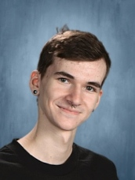
Jacob Clements
Parents/Guardians: Jeff Clements and Angee Reniger. Jacobs future plans are to attend Kellogg Community College where he will join the graphic design program.

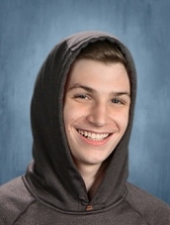
Javid Brown
Parents/Guardians: Jeff Brown and Kimberly Brown, Javid is glad to be done with high school and looking forward to what life has to offer him. Javid is undecided about future endeavors but is looking forward to being successful and happy with whatever he decides.

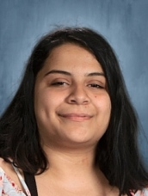
Shannon Cortes
Parents/Guardians: Maria Cortes, Shannon is glad to be done with highschool and looking forward to what life has to offer her in the future.

