|  |
| --- |
|  |
| May 2017 Newsletter |
|  |

Calhoun Community High School

Like us on Facebook 

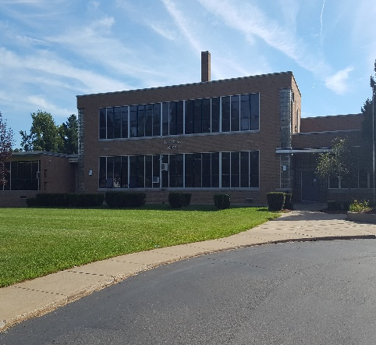**Upcoming Events**

5/5 Student Support Day

5/9-5/11 Parent/Teacher Conferences 3:00-4:00 each day

5/25 Graduating Seniors Last Day of School!



5/26 Student Support Day

5/29 Memorial Day, No School

|  |
| --- |
|  |
|  |
|  |
| Breaking News Congratulations to the Rotary Senior of the Month for May:  Casey Margherita  No Picture Found |

15 Arbor Street, Battle Creek

www.calhounhs.org T: 269-565-4782

**May Birthdays**

Cody Field 5/2

Marianna Allen 5/3

Kasey Hodgkinson 5/4

Mrs. Case 5/4

Alec Rogers 5/5

Toriano “Jimmy” Curry 5/9

Gabby Eggleston 5/15

Dana “Carlito” Hill 5/17

Alexis Thomas 5/21

Mrs. Olsen 5/28

|  |  |  |
| --- | --- | --- |
|  |  |  |
|  |  |  |

**May Quote of the Month:**



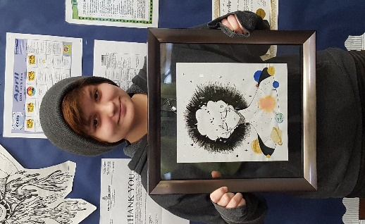

**Congratulations to May Leaders of the Pack:**

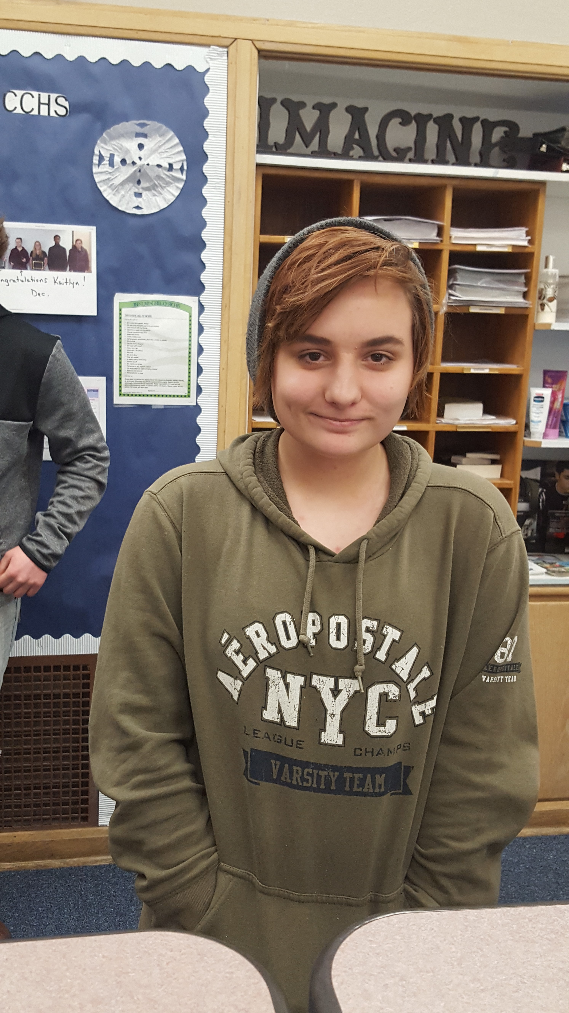 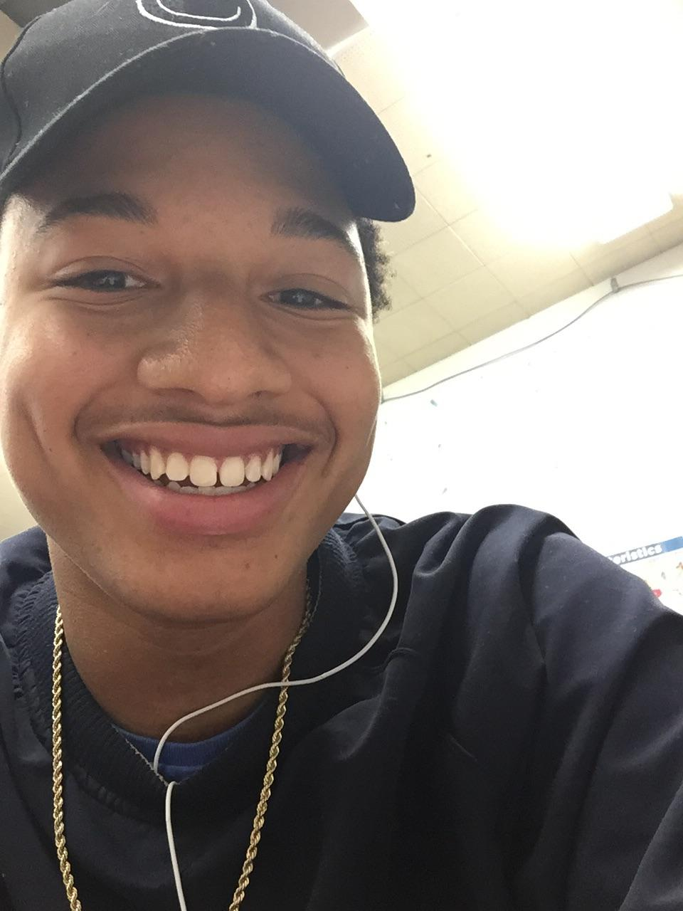 

Ryleigh Smith Dea’Shon Heard Dana Hill

**Important Announcements:**

* Just a reminder; according to the Student Handbook, Students may not leave the building without permission from a parent/guardian if they are under 18. If a situation arises where a minor needs to leave, either Mrs. Reid or Mrs. Wilsey needs to speak to a parent prior to the student leaving. Once students leave the building, they are not allowed back inside.
* Parent/Teacher Conferences will be held on May Tuesday 9, Wednesday 10, & Thursday 11 every day from 3:00 – 4:00 p.m.
* Graduation Ceremony will be held in the Lakeview Middle School Auditorium on June 8th, at 7:00 p.m. Practice will be at 11:30 (students only), including photos and lunch will be provided. Feel free to call the office with any questions (269) 565-4782

Our very own Ryleigh Smith has entered her piece in the Congressional Art Competition.  This competition began in 1982 to provide an opportunity for members of Congress to encourage and recognize the artistic talents of their young constituents.  Since then, over 650,000 high school students have been involved with the nationwide competition.  Good luck Ryleigh, we are so proud of you!